Software Business Project

Student name: Hyechan Shin
Student number: 003991873
Selected case: A
Company name: Sujava

T1.2 – Start Your Software Business Project

Case and Company Name

I have selected Case A and given the company name of ‘Sujava’. Sujava means ‘smooth,’ ‘seamless’ in Finnish, which it fits well with the consultancy providing client software delivery smooth and seamlessly.

Currently, there is no company registered under this name in Finland.

Initial Opportunity or Challenge

A vast number of travel and tourism industry still relying on manual, repetitive, undigitalized work processes, such as email, spreadsheets, paper forms. In Sujava, we are specialized to provide software that have centralized booking system, integration and optimization that makes non IT users to get into, this can save cost for clients to train the staff. Reuse of the code is a great opportunity in Sujava, since it is targeting mainly for the travel and tourism sector.

A key difference is that Sujava provides digital services that is complied with ITIL (Version 5) framework for incident, change, and problem management for the platform that builts, which builds a strong advantage for travel clients.

The main challenge for Sujava is the seasonality of the travel and tourism industry. A tourism in general heavily rely on the specific seasons, for instance in Finland, summer and winter are the most popular seasons, which can lead to unstable cash-flow growth throughout the year.

Your Company's Software Business

Describe more specifically what your company sells and to whom. What characteristics make it a product, service, or hybrid software business? Based on the Section 1 materials, briefly discuss how these characteristics affect the company's potential to scale.

Sujuva sells custom software platforms, which includes centralized booking systems, channel manager integration and management tools, as well as disaster recovery tools, along with ongoing ITIL-based support. Sujuva’s main customer pool is travel and tourism sectors. This can be travel agnecies, hotels. This set of combination makes Sujuva a hybrid software business (Cusumano, 2008) as each client still needs consulting to fit their needs and reviewing the workflows, but most of the code can be reused as Sujuva focuses on a single sector.

T5.2 – Business Model

Business Model Canvas
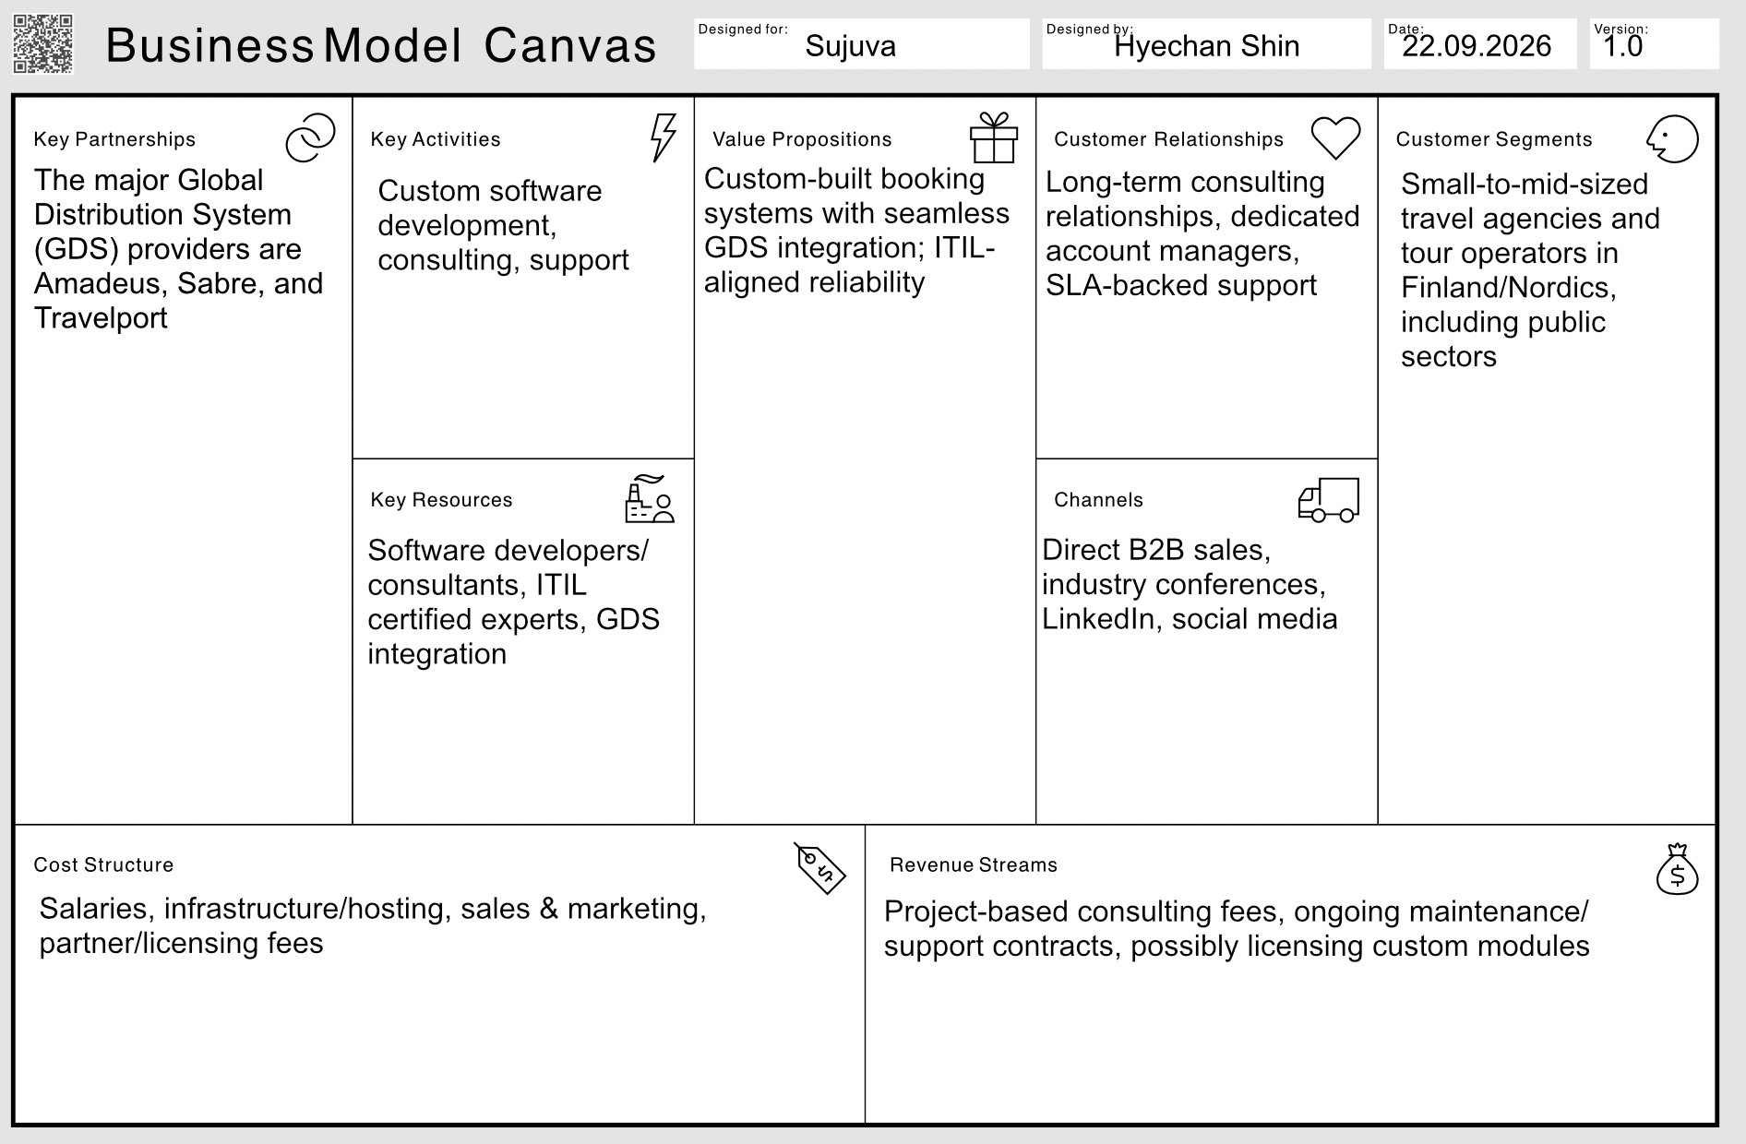

Your Business Model

Sujuva provides custom software platforms to the travel and tourism industry, preferably to small and mid-sized companies located in Nordic countries, as well as the public sector to help them overcoming the challenges with digitalization, automation the work processes and minimize the manual work and repetitive tasks. Centralized reservation systems that integrate with GDS systems like Amadeus, Sabre, and Travelport will be one of the main deliverables because some of the smaller agencies are still using disconnected systems, which generate additional manual effort. On top of this, Sujuva also implemented with ITIL-based framework to all of its projects, which brings additional value to the service offering, such as clearly defined roles, IT services and software processes, incident management, knowledge management.

Key Business Model Choices

There are several areas of the Business Model Canvas that are especially important to Sujuva. The first one is Value Proposition. The uniqueness of the solution offered by Sujuva – custom software and process based on ITIL, is what sets it apart from generic software vendors, and that is the reason why client prefer to pay for custom solution rather than for cheaper solutions. The second area is Customer Relationships. Since Sujuva is entrusted withi an extremely vital sysetm, a dedicated account manager and support based on SLAs build the necessary trust that ensures high satisfaction from the client. The third area is Revenue Stream. Sujuva’s main revenue comes from the project fees and maintenance fees. Also once the software is built, it is possible for them to use the same software concept to build a similar projects, reducing the development cost from the scratch. The technology evolves and the way of our working is also evolving. For instance, the ITIL framework itself gets updated every few years, which means ongoing maintenance of the ITIL implementation and continuous engineering work is required.

Software-Specific Business Model

Sujuva acts as a hybrid software company. The development of custom reservation systems resembles a Software-as-a-Product (SaaP) arrangement, an instance of one-time customization. However, the maintenance function is much closer to a SaaS service, because Sujuva continues to earn after delivery. Sujuva offers custom platforms such as reservation systems, integration into GDS, and ITIL-based support to travel agencies and tourism authorities. It is evident that the company operates as a hybrid software business (Cusumano, 2008), as its customers will require assistance in integrating the system into their workflow, yet, Sujuva can reuse its code and process configuration as it is engaged only in one industry.

Coherence of the Business Model

The most parts of the model support each other well. Key resources like ITIL expertise and GDS integration knowldge makes it possible for Sujuva to carry out its Key Activities. These activities result in Value Proposition that is the reason why customers use the Customer Relationships and make payments using the Revenue Streams of Sujuva.

Additionally, there is a strength and a weakness. Strength - the income from maintenance comes naturally because of clients’ trust, not separately. Weakness - dependence on several GDS partners. If something changes in the price policy or access conditions of Amadeus, Sabre, and Travelport, it will affect negatively Key Partnerships, Key Activities and Value Proposition simultaneously.
T6.2 – Revenue and Pricing Model

Pricing Proposal
 | Starter | Growth | Enterprise
Best for | Single business | Multi-property businesses | Hotel chain/ large agency network
Setup Fee (One time) | €1,500 | €4,500 | Custom quote
Subscription | €99/month | €299/month | From €800/month
Billing Unit | Per property | Per property | Per property + Booking volume
Payment frequency | Monthly or annualy (anual subscription will have 10% discount) | Monthly or annualy (anual subscription will have 10% discount) | Annual contract
What’s included | Booking system, maintenance, 1 channel-manager integration, ITIL support | All Starter features + prioritypriority incident response + phone & chat support | All growth features + Full integration suite, dedicated account management, Top-tier support with strict SLA.
Key differences | Core platforms only | Adds resilience + faster support | Compatible with standardized enterprise SLA

Revenue Model

The two major sources of revenue for Sujuva include setup fees and the monthly or annual subscription. Nevertheless, Sujuva is not a one-off implementation as it needs to be maintained, updated, and supported, which generates recurring revenue. Thus, there is room for services and products. Sujuva offers an integrated booking solution combined with ITIL Incident, Change, and Problem Management.

Price Formation

Sujuva's business model combines cost-based and value-based pricing. The minimum cost is set up in relation to the setup cost involved due to the fact that setting up involves considerable consultation and integration efforts on account of the need to integrate the software with the client systems. The subscription, by contrast, is priced using a value-based approach: a client's willingness to pay scales with the value Sujuva creates, such as time saved and revenue protected during outages through ITIL-based incident management. A comparison of the pricing model of Sujuva against similar competitors also shows that it sits within a reasonable, competitive range, while the ITIL-based support model helps it stand out in the market.

Pricing Model

The pricing of Sujuva is based on three of the factors described by Buxmann, Diefenbach, and Hess (2013). The Payment flow is a combination of one-time and recurring payments: clients pay a setup fee once, then a monthly or annual subscription. The billing unit is per property as this will be scalable depending on how much value the customer gains and there is no need to have complicated use of measurements. Bundling is used for the disaster recovery module and faster support response times, which are included in the higher tiers rather than sold separately. Price differentiation and dynamic pricing are not used, since fixed tier pricing is less complicated to understand, and it will create more trust in SME customers.

Customer Value
Integrating advanced technology with a structured ITIL framework provides Sujuva’s clients not only with a booking service but with reliability as well. For travel agencies and hotels, a booking, payment system failure or outage causes huge consequences, which can lead to lost trust, lost customers, and lost revenue. Furthermore, this reliability is also hard to find among competitors, making customers more eager to pay for its subscription instead of purchasing a cheaper one with less disciplined. By partnering up with Sujuva's dependable platform, clients can also build their own reputation for reliability, helping them stand out among their competitors.
T9.2 – Software Economics and Open Source

Software Economics

Switching Costs, Standards and Lock-In

Open-Source Decision

Changes to Earlier Decisions
If you have changed any earlier decisions, briefly explain what you changed and why. If you have not made changes, state this.

T10.2 – AI Stress Test Your Software Business

Product and Customer Value

Build, Buy or Combine

Economics and Monetization

Competitive Advantage

Changes to Earlier Decisions
If you have changed any earlier decisions, briefly explain what you changed and why. If you have not made changes, state this.

T11.2 – Final Software Business Challenge: Respond to an RFP

Bid / No-Bid Decision

Proposed Solution

Value Proposition and Competitive Position

Pricing Proposal

Risks and Contract Considerations

Executive Proposal

Final Changes to the Software Business Project
Briefly identify any significant changes you made to your company or earlier business decisions and explain why. If you have not made significant changes, state this.

Declaration of AI Use
AI tools used:
ChatGPT
How AI was used:
ChatGPT - Grammar check
ChatGPT was used to get the general idea T2 business model examples of

References
Cusumano M.A. (2008). The Changing Software Business: Moving from Products to Services
Buxmann, P. (2013). The software industry: economic principles, strategies, perspectives. Springer.
Cespedes, F. V. (2010). Pricing, profits, and customer value (HBS Background Note 811-016). Harvard Business School.

